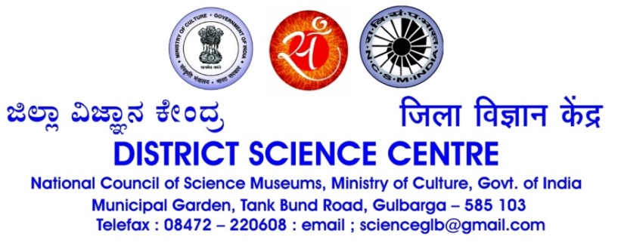

INNOVATION FESTIVAL
19-21 Feb 2018

Berief note on Innovation festival:

Dist. Science Centre, Kalaburagi is one of the units of National Council of Science Museums, functioning under the purview of Ministry of Culture, Govt. of India. It is the only one of its kinds in Karnataka and first Science centre opened in South India. It was dedicated to the people of Kalaburagi on 6th January 1984. This centre is under the administrative control of Visvesvaraya Industrial & Technological Museum, Bangalore. The Centre has made yeoman service not only to the students’ community but also to the general public in Hyderabad Karnataka area for the last 34 years. Centre has visitors’ footfall of about 2 lakh per annum.

We are extremely happy to inform you that Dist. Science Centre, Kalaburagi is organising an ‘2nd Innovation Festival – IGNITE 2018 ’ from 19 - 21 Feb. 2018. In this festival young innovators/grass root innovators, would get an opportunity to showcase their innovation to large number of people who visit this centre.

Innovation festival creates great opportunity for the students to showcase their innovative projects/device/kit/experiments/machineries during this festival. I would therefore, request you to please motivate the students to send synopsis of innovative projects along with their name and contact details to us latest by 13th February 2018. After scrutiny suitable projects will be included in the innovation festival. An official invitation will be sent to the selected students, whose project will be selected for display.

Brief information on innovation festival

- Inauguration: 19.02.2018 at 10.30 AM
- Valediction & prize distribution: 21.02.2018 at 3.30 PM.
- No. of participants for each project : one or Two
- The space allotted for each project : 4 feet x 2 feet with a backdrop of 8’x4’
- Registration is free
- Certificates & suitable awards will be given to the participants
- Centre will take care of the hospitality during the 2 days stay (for outstation participants).
- Centre will reimburse AC 3 tier train fare on production of journey tickets (for outstation students)
- Outstation participants can plan their return journey on 21.02.2018 by late evening.

*******
What is innovation
Innovation is the process and outcome of creating something new, which is also of value. Innovation involves the whole process from opportunity identification, ideation or invention to development, prototyping, production marketing and sales, while entrepreneurship only needs to involve commercialization. There are several types of innovation - Process, product/service, strategy. Innovation vary in degree of newness, Incremental to radical .

********
INFORMATION TO PARTICIPANTS
- Display of Innovative projects (Not Science fair type).
- Challengers’ corner. Throw different challenges to the visitors which they have to solve in a given time. The winners are given cash prize on the last day of the event.
- Demonstrations on pottery, cottage industries products, craft works etc.
- Workshops on Paper engineering, Origami, Clay modeling etc.
- Make from Scrap corner - People will be provided with scrap materials and they can make anything out of it showing their creativity. The best ones can be given some certificates and cash award.
- Lectures by Startup companies on how they conceived the idea and how they realized their dreams. Preferably from Kalaburagi region.
- ‘Do it yourself workshop’ on some items on craft, electronics like FM radio assembly, bucket radio, small amplifier that can be used as Boom Box etc.
- Magic Shows, large attractive demonstrations.
It is open to all (students / public, grass root innovators). Institutions may involve with their innovative projects.

Information to the Members of the innovation hub
- Members shall perform innovative activities. Products / projects made by them shall be displayed in the Innovation festival.
- Best innovative products / projects prepared by the students will be selected to participate in IRIS, INSEF and Google Science Fair. We encourage & guide on the ideas from members to make the project, test it and present it. This is a yardstick to measure & decide functionality of Innovation hub. Best ideas / projects may lead to patenting / copyright
- In the ‘do it yourself’ session of innovation festival public may bring their electrical appliances and learn to trouble shoot and Set right it. To find out, hurry up and register for our workshop with the details of the item you are bringing.
*******

